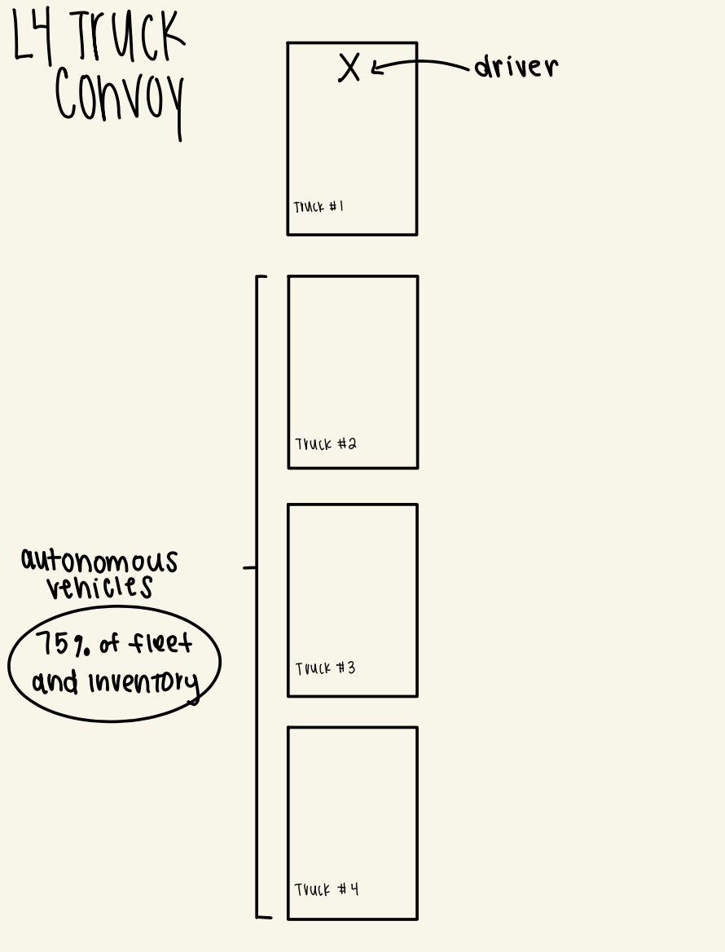

- Fleet size: 134,382 trucks (the above model counts as four trucks)

